**RC CAR INTERNAL BLOCK**

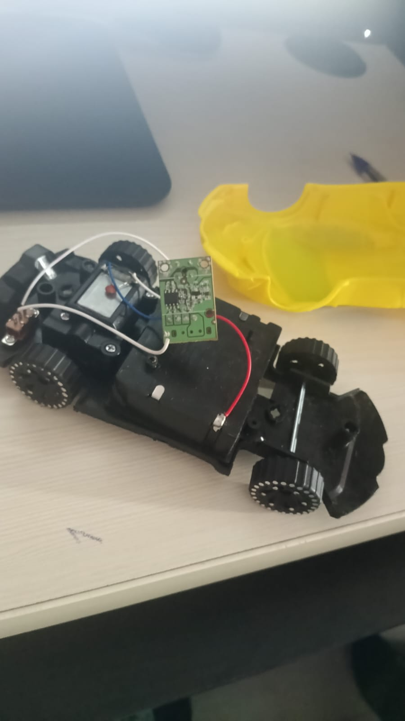

**1. Chassis (Black Plastic Body)**

**What it is:**  
The black plastic frame on which all parts are mounted.

**Function:**

* Holds motor, wheels, PCB, battery and wires
* Provides mechanical strength
* Keeps components aligned

**Material:** ABS plastic (lightweight, cheap, durable)

**2. DC Electric Motor (Drive Motor)**

**What it is:**  
A DC brushed motor that rotates when voltage is applied.

**Function:**

* Converts electrical energy → mechanical rotation
* Drives the rear wheels through gears

**Working principle:**

* Current flows through motor coils
* Magnetic field is created
* Interaction with permanent magnets causes rotation

**Why DC motor is used:**

* Simple
* Cheap
* Easy to control direction by reversing polarity

**3. Gearbox (Attached to Motor)**

**What it is:**  
A set of plastic gears connected to the motor shaft.

**Function:**

* Reduces motor speed
* Increases torque
* Transfers power to wheels

**Why needed:**  
DC motors rotate very fast but with low torque. Gears slow it down and make the car strong enough to move.

**4. Wheels and Axle**

**What they are:**  
Plastic wheels connected using metal or plastic axles.

**Function:**

* Convert rotational motion into forward/backward motion
* Provide traction with the ground

**Observation:**  
Rear wheels are powered, front wheels are free (toy-grade RC).

**5. Main Control PCB (Green Board)**

This is the receiver + motor controller combined on one PCB.

**Components on this PCB:**

**a) RF Receiver IC**

**What it is:**  
An integrated circuit that receives radio signals from the remote.

**Function:**

* Decodes signals like Forward, Backward, Left, Right
* Sends control signals to motor driver circuit

**Frequency:**  
Usually 27 MHz or 49 MHz (common in toy RC cars

**b) Motor Driver Transistors / IC**

**What it is:**  
Small black components near the motor wires.

**Function:**

* Supplies high current to motor
* Controls motor ON/OFF and direction
* Acts like a simple ESC (Electronic Speed Controller)

**Why needed:**  
Receiver IC cannot drive motors directly.

**c) Capacitors (Small cylindrical / ceramic parts)**

**Function:**

* Reduce electrical noise
* Stabilize voltage
* Protect circuit from motor sparks

**d) Resistors**

**Function:**

* Control current flow
* Bias transistors and ICs

**e) Solder Pads / Terminals**

**Function:**

* Connect battery, motor and antenna wires

**6. Antenna Wire (White Long Wire)**

**What it is:**  
A single long wire connected to receiver PCB.

**Function:**

* Receives radio signals from transmitter
* Length is tuned to signal frequency

**Important:**  
Longer antenna = better rang

**7. Battery (Inside Car – not fully visible)**

**What it is:**  
Usually AA cells or rechargeable Ni-MH battery pack

**Function:**

* Supplies power to motor and PCB

**Typical Voltage:**

* 3V – 6V

**8. Power Switch (Small mechanical switch)**

**Function:**

* Turns car ON or OFF
* Disconnects battery when not in use

**REMOTE CONTROLLER (TRANSMITTER) SIDE**

**9. Transmitter PCB (Brown Board – KY-XD2ST)**

**a) Push Buttons (2 Black Buttons)**

**Function:**

* Send command signals when pressed
* One button: Forward/Backward
* One button: Left/Right

**b) RF Transmitter Circuit**

**Function:**

* Generates radio frequency signal
* Modulates signal based on button press
* Sends command to car

**c) Antenna (Thin Metal Wire)**

**Function:**

* Radiates radio waves
* Improves transmission range

**d) VCC, GND Pads**

**Meaning:**

* **VCC** → Battery positive
* **GND** → Battery negative

**10. Working Principle (Complete System)**

1. User presses button on remote
2. Transmitter sends RF signal
3. Car antenna receives signal
4. Receiver IC decodes signal
5. Motor driver activates DC motor
6. Gears rotate wheels
7. Car moves in required direction

**11. Why This RC Car Is Toy-Grade**

* No microcontroller (simple IC only)
* No proportional speed control
* Fixed ON/OFF movement
* Low power motor
* Cheap RF system

**12. Advantages**

* Simple design
* Low cost
* Easy to understand
* Good for learning basics of electronic

**13. Applications**

* Toys
* Educational projects
* RC learning kits
* Demonstration models

**14. Conclusion (For Document)**

This RC car uses a simple RF-based control **sys**tem with a DC motor, receiver PCB**,** control circuit to drive the motor and wheels.

gearbox, and battery. The transmitter sends commands wirelessly, which are received and processed by the car’s

Bottom of Form

.

**Internal Block Diagram of an RC Car**

Transmitter (Remote)

-----------------------

| Control Buttons |

| Encoder Circuit |

| RF Transmitter |

| Antenna |

-----------------------

|

RF Signal (27/49 MHz)

|

v

-----------------------

| Antenna |

| RF Receiver |

| Decoder Circuit |

| Motor Driver (ESC) |

| Power Control |

-----------------------

|

-------------------

| DC Motor(s) |

| Gearbox |

| Wheels |

-------------------

|

Mechanical Motion

-----------------------

| Battery / Power |

-----------------------

**Explanation of Each Internal Block**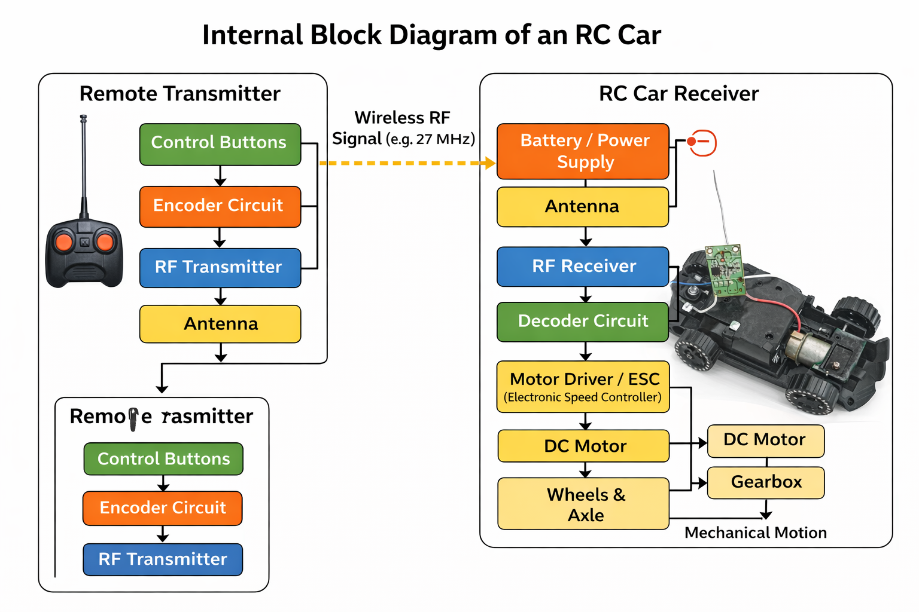

↓

**1. Battery / Power Supply Block**

**Function:**

* Supplies electrical power to all internal components.

**Details:**

* Typically 3V–6V (AA cells or rechargeable pack)
* Powers receiver circuit and motor driver

**Importance:**  
Without battery, the RC car cannot operate.

**2. Antenna Block (Receiver Side)**

**Function:**

* Receives radio frequency (RF) signals sent from the remote.

**Details:**

Usually a long single wire Length matched to operating frequency­­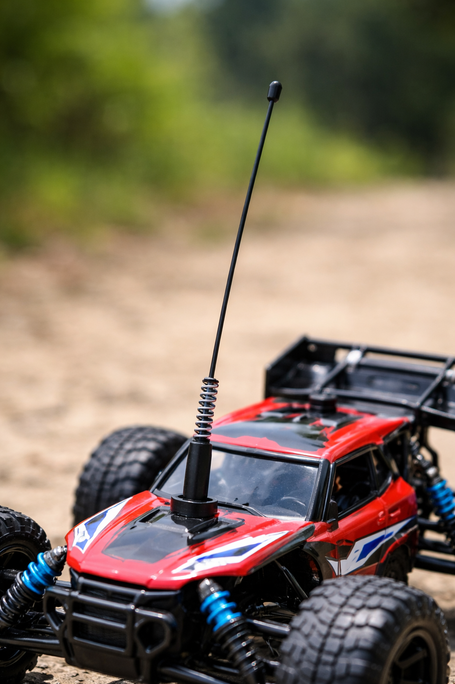

**3. RF Receiver Block**

**Function:**

* Receives and amplifies RF signals
* Filters unwanted noise

**Details:**

* Operates at fixed frequency (27 MHz / 49 MHz)
* Converts RF signal into electrical data

**4. Decoder / Control Logic Block**

**Function:**

* Decodes received signals
* Determines command (forward, backward, left, right)

**Details:**

* Uses simple IC (not a microcontroller in toy RC)
* Produces control signals for motor driver

**5. Motor Driver / ESC Block**

**Function:**

* Controls motor direction and ON/OFF operation
* Supplies high current to motor

**Details:**

* Uses transistors or H-bridge circuit
* Protects control circuit from motor current

**Why needed:**  
Receiver IC cannot directly drive motors.

**6. DC Motor Block**

**Function:**

* Converts electrical energy into rotational motion.

**Details:**

* Brushed DC motor
* Direction controlled by polarity change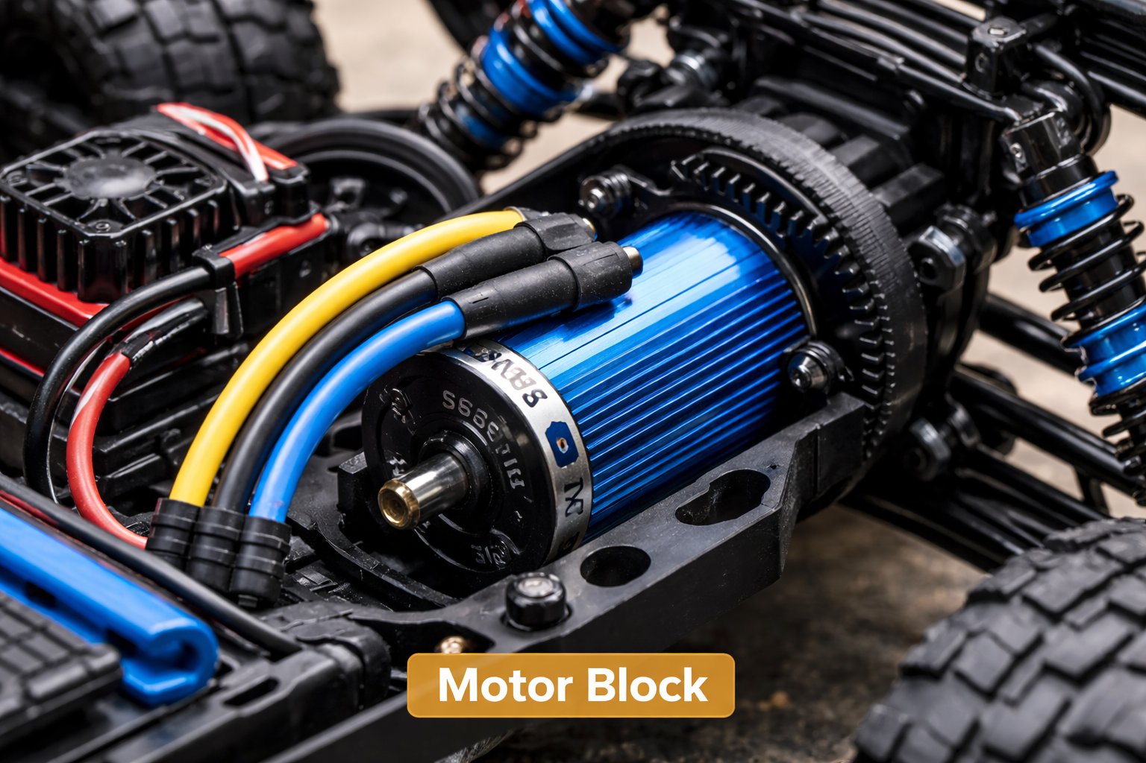

**7. Gearbox Block**

**Function:**

* Reduces speed
* Increases torque

**Details:**

* Plastic gear train
* Connects motor to wheels

**8. Wheel & Axle Block**

**Function:**

* Converts rotation into vehicle movement.

**Details:**

* Rear wheels driven
* Front wheels used for steerin

**9. Steering Mechanism Block (If Present)**

**Function:**

* Controls left/right movement.

**Details:**

* Small DC motor or mechanical linkage
* Common in toy-grade RC cars

**10. Power Switch Block**

**Function:**

* Turns car ON or OFF
* Disconnects battery when not in use

**Short Working Description (For Exams)**

When a button is pressed on the transmitter, an RF signal is sent through the antenna. The receiver antenna in the RC car captures this signal and passes it to the RF receiver and decoder circuit. The decoded command is sent to the motor driver, which controls the DC motor. The motor drives the gearbox and wheels, causing the RC car to move in the desired direction.

**One-Line Conclusion**

The internal blocks of an RC car work together to receive wireless commands, process them electronically, and convert electrical energy into controlled mechanical motion.